Instructor Quick Reference

Guide

**Instructor Quick Reference Guide**

MyLearning, Capgemini’s global Learning Management System, provides you with information on the activities you are scheduled to teach

Table of Contents

**Instructor Schedule** 2

**Manage Activity Roster** 3

**Instructors can mark completions** 5

**Activity Sign-in Sheet** 6

**Help** 7

**Access MyLearning at:** <https://mylearning.capgemini.com>

**Instructor Schedule**

If you are defined as an instructor in MyLearning, you can view sessions that you are scheduled to teach from the Instructor Schedule page

**Self-Icon –View Full Menu - Learning – Instructor Schedule**

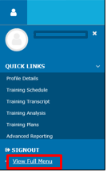

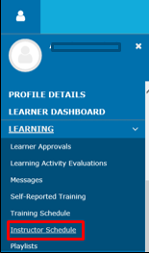

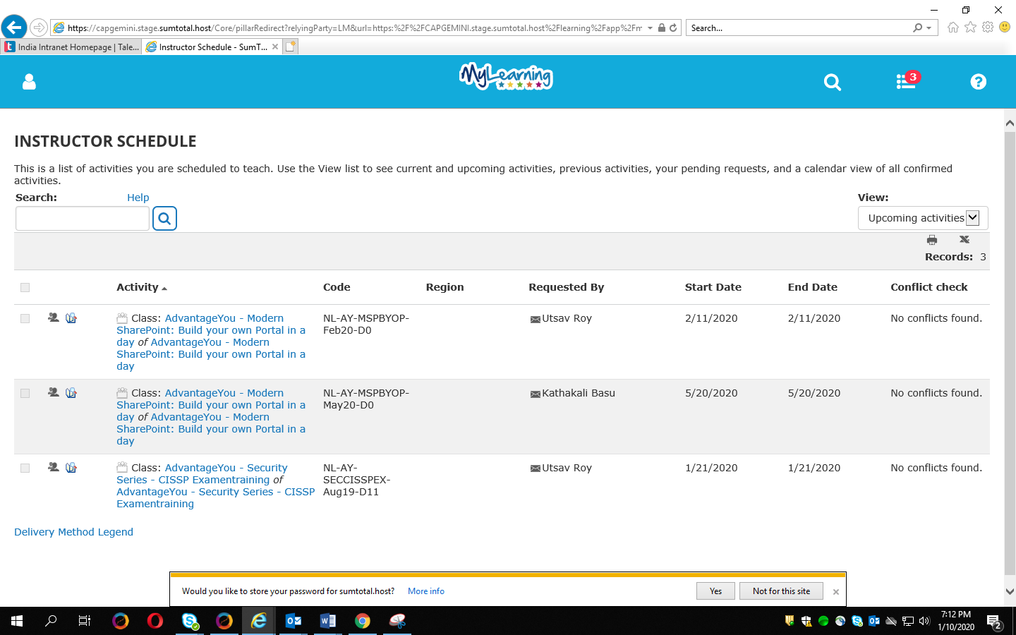

Instructors can view their schedule by:

**Current activities** - Shows the current activities you are scheduled to teach.

**Pending Request** – Displays pending activities

**Calendar** - displays the instructor schedule in an interactive calendar view.

**Upcoming activities** - Shows future activities

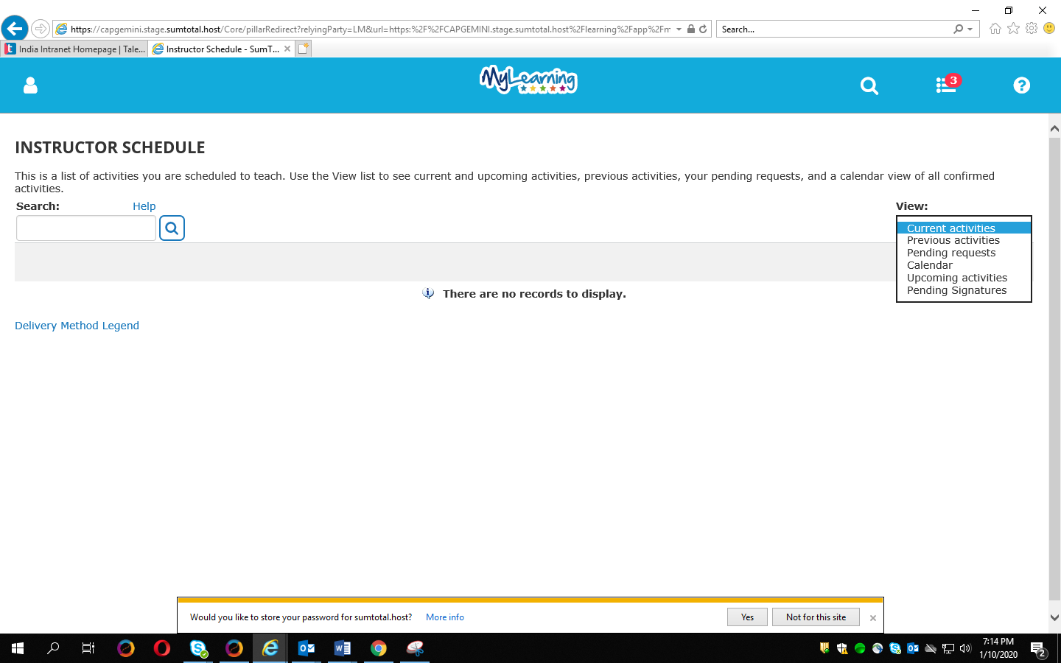

**Manage Activity Roster**:

To view Activity Roster:

* In the Header menu, click on Self menu>View Full Menu
* Navigate to Learning > Instructor Schedule.
* Locate the learning activity and click on the icon on the left marked red. 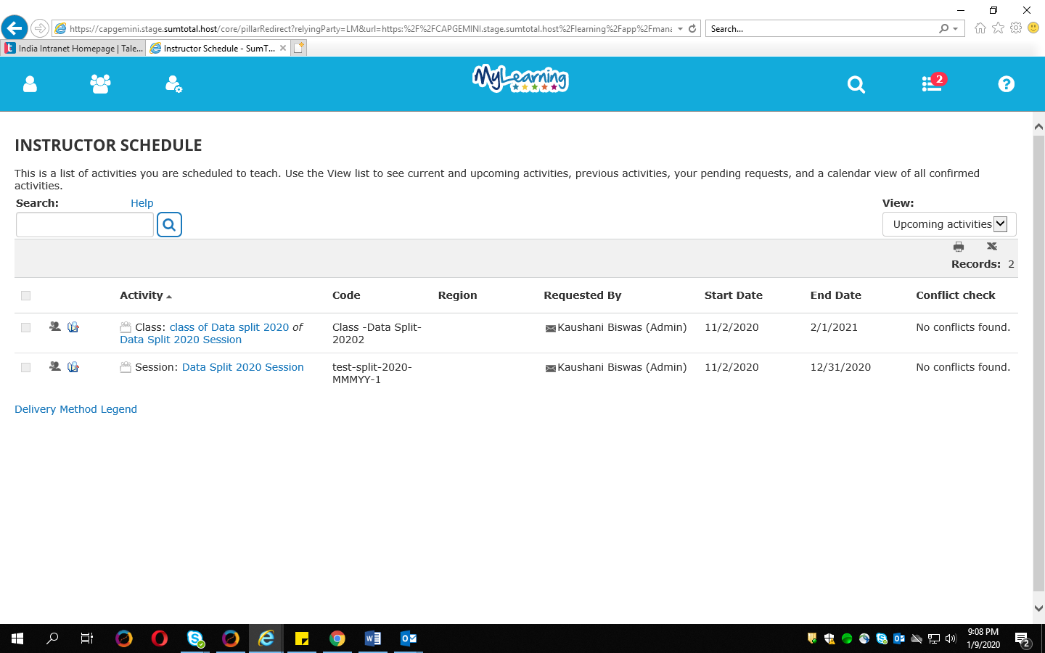

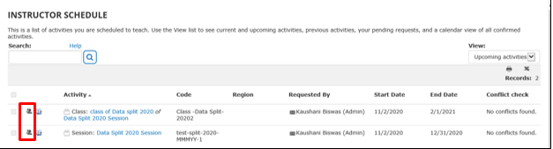

After clicking on the said icon you can view the Roster. Click on the **search** icon to get the list of participants

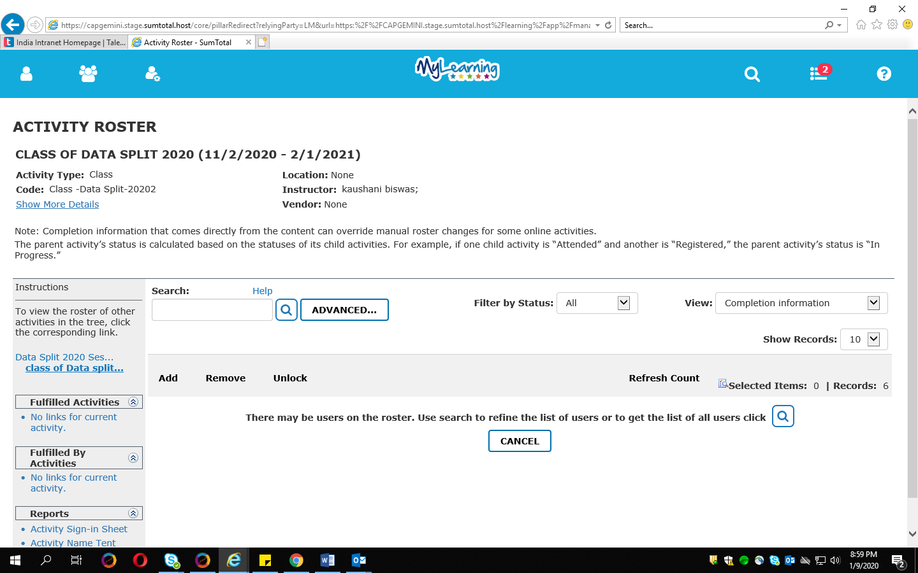

Within the Activity Roster, you can change the View to see a listing of participants in different stages of the registration process as shown below

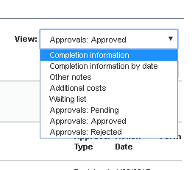

Click on Excel icon to export the session roster to Excel.

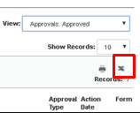

Click on Print option to generate the report – Select save as PDF

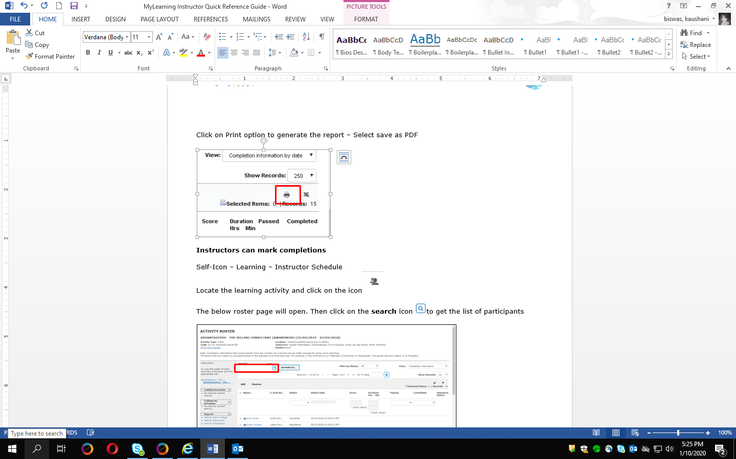

**Instructors can mark completions**

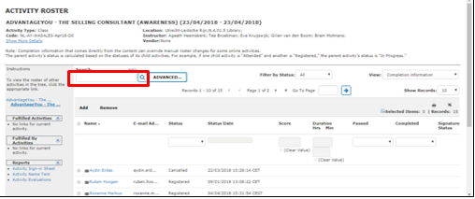

Choose a person listed on roster by selecting the check box to the left of the name.

Open the **Status** drop-down list and choose either Attended or Cancelled.

Do not change the status date.

For all Attended participants, select Yes or No in the Completed column.

Click **Apply** button.

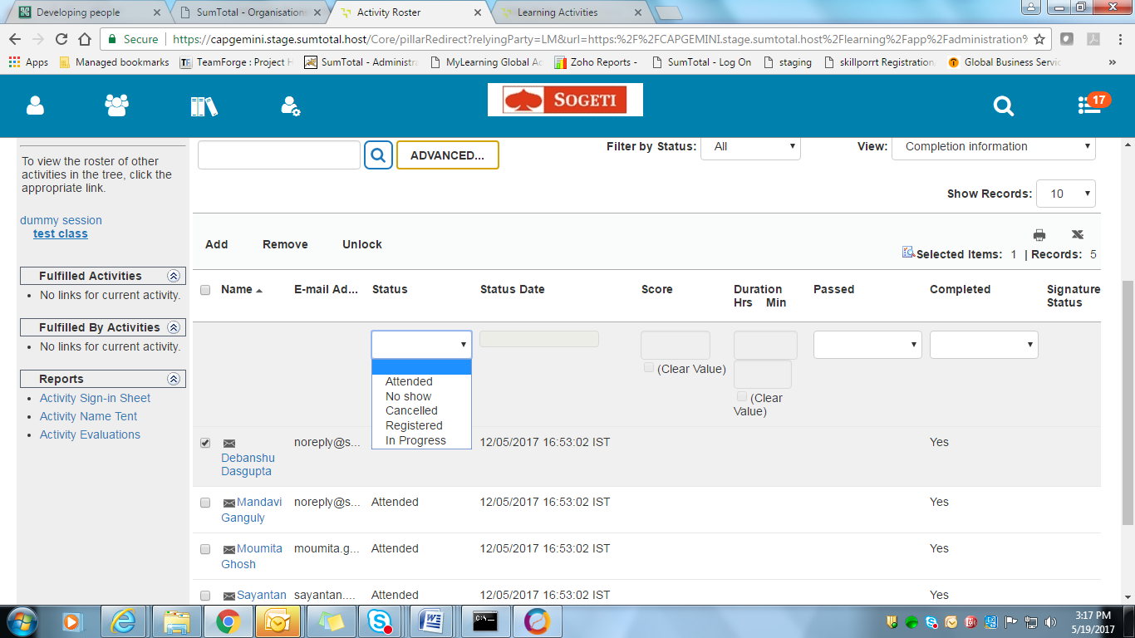

**Activity Sign-in Sheet**

This report is designed to support attendance tracking for instructor-led training. It generates a printable form of the activity roster, including all registered participants, and can be used for taking attendance in class.

On the left hand side bar, under Reports, click on the **Activity Sign-in Sheet** link

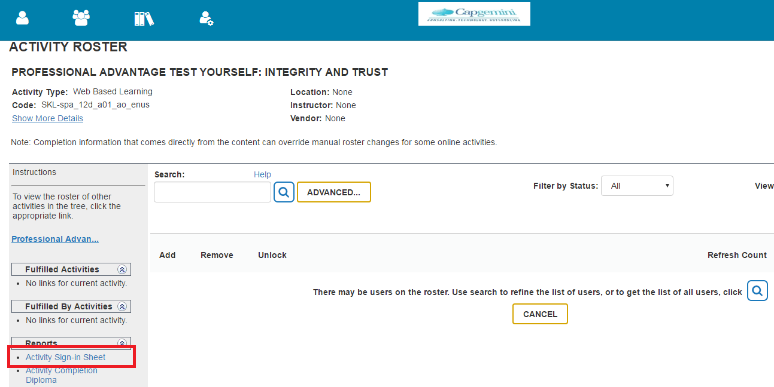

Click **Print**

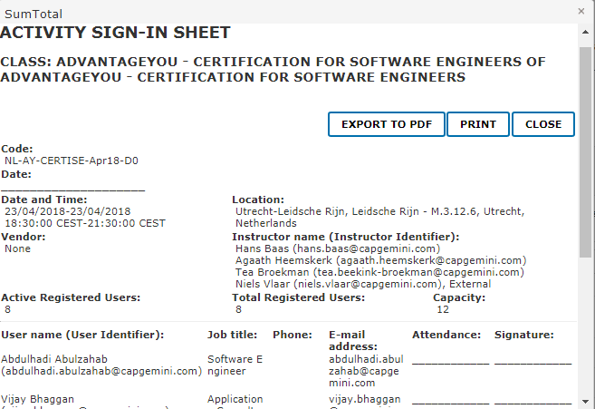

Note: An instructor cannot register for an activity for which he/she is an instructor. If you try to register, your registration will blocked and the below error will be displayed.

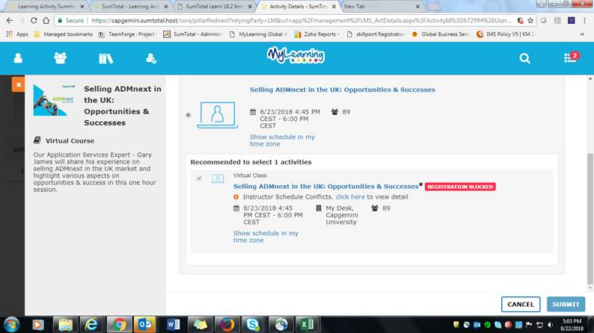

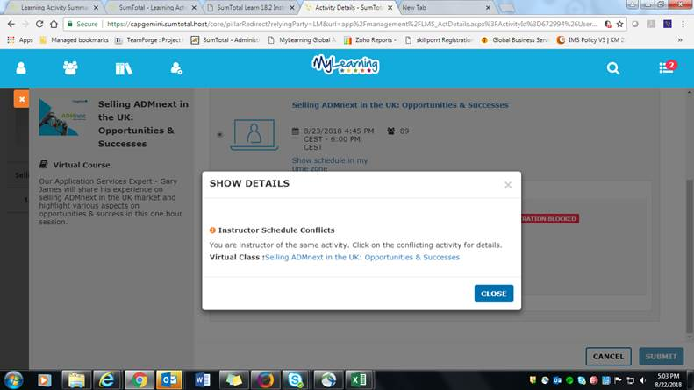

**Help**

For help, please contact your local L&D team.

About Capgemini

A global leader in consulting, technology services and digital transformation, Capgemini is at the forefront of innovation to address the entire breadth of clients’ opportunities in the evolving world of cloud, digital and platforms. Building on its strong 50-year heritage and deep industry-specific expertise, Capgemini enables organizations to realize their business ambitions through an array of services from strategy to operations. Capgemini is driven by the conviction that the business value of technology comes from and through people. It is a multicultural company of 200,000 team members in over 40 countries. The Group reported 2016 global revenues of EUR 12.5 billion.

Learn more about us at [www.capgemini.com](http://www.capgemini.com)

This message contains information that may be privileged or confidential and is the property of the Capgemini Group.  
Copyright © 2017 Capgemini. All rights reserved.